CRM SOftware


Contents
- Why 73% of Indian SMEs Choose the Wrong CRM 2
- The 7-Point CRM Selection Framework 2
- CRM Comparison: What You Actually Need vs. What You Get 3
- The 30-Day CRM Implementation Roadmap 4
- ROI Calculator: Your CRM Investment Returns 5
- Red Flags: CRMs to Avoid 6
- Industry-Specific CRM Checklist 6
- Quick Decision Matrix 7
- Your Next Steps 7
- Success Stories: Businesses That Got It Right 8
- Bonus: CRM Implementation Checklist Templates 8
- The Bottom Line 9
- Ready to Choose Your Perfect CRM? 9
- About Greendot Management Consultants 10

HOW TO CHOOSE THE PERFECT CRM THAT ACTUALLY WORKS

Why 73% of Indian SMEs Choose the Wrong CRM
The Painful Reality Most Business Owners Face:
You've probably tried one of these "solutions":
- Excel sheets that crash with too much data
- WhatsApp groups where important leads get buried
- Expensive CRMs like Salesforce (₹1,500+ per user/month)
- Complex systems that your team refuses to use
- "Free" CRMs with hidden costs that appear later
The Hidden Cost: Every wrong CRM choice costs you 6-12 months of lost productivity and ₹2-5 lakhs in implementation failures.

The 7-Point CRM Selection Framework
Point 1: The India-First Test
Does it work on 2G networks?
- 60% of Indian areas still have inconsistent internet
- Your CRM should load in under 5 seconds on slow connections
- Offline capability for field teams is non-negotiable
Point 2: The WhatsApp Integration Test
Can you communicate directly from the CRM?
- WhatsApp is how Indian businesses communicate
- Email integration alone isn't enough
- Look for native WhatsApp API integration
Point 3: The Simplicity Test
Can your least tech-savvy employee use it?
- If training takes more than 2 days, it's too complex
- Check if data entry requires minimal clicks
- Ensure mobile app is as functional as desktop
Point 4: The True Cost Test
What's the REAL total cost for 3 years?
Hidden Costs to Calculate:
□ Setup and implementation fees
□ Training and onboarding costs
□ Per-user monthly charges
□ Storage and data limits
□ Integration and customization fees
□ Support and maintenance costs
□ Migration costs if you switch later
Point 5: The Scalability Test
Will it grow with your business?
- Can you add users without breaking the bank?
- Does performance slow down with more data?
- Are advanced features locked behind expensive plans?
Point 6: The Data Security Test
Is your customer data safe?
- Auto-backup functionality
- Data encryption standards
- Data ownership rights (crucial!)
- GDPR compliance for future expansion
Point 7: The Support Test
Can you get help when needed?
- Local language support availability
- Response time for critical issues
- Training and implementation support
- Community or knowledge base quality

CRM Comparison: What You Actually Need vs. What You Get
Feature | Your Business Needs | Expensive CRMs Give | Smart Choice Gives
Lead Tracking | Simple, visual pipeline | 50+ fields to fill | Clean, focused tracking
Communication | WhatsApp + Email | Email only | Native WhatsApp integration
Pricing | ₹500-2000/month total | ₹1500+ per user/month | Affordable flat rates
Setup Time | Ready in 1 week | 2-3 months implementation | Quick 1-week setup
Training | 1-2 days max | Weeks of training needed | Intuitive, minimal training
Support | Local, responsive | International, slow | Local support team

The 30-Day CRM Implementation Roadmap
Week 1: Foundation Setup
Days 1-2: Data Preparation
- Export existing customer data from Excel/other tools
- Clean and organize contact information
- Define your sales process stages
- List all team members who need access
Days 3-5: System Setup
- Create user accounts and set permissions
- Configure sales pipeline stages
- Set up basic automation rules
- Import and organize your customer data
Days 6-7: Integration Setup
- Connect WhatsApp Business API
- Link email accounts
- Set up calendar synchronization
- Configure mobile app access
Week 2: Process Implementation
Days 8-10: Lead Management Setup
- Create lead capture forms
- Set up lead assignment rules
- Configure follow-up reminders
- Test lead-to-customer conversion flow
Days 11-14: Communication Setup
- Create email templates for common responses
- Set up WhatsApp quick replies
- Configure automated follow-up sequences
- Train team on communication workflows
Week 3: Advanced Features
Days 15-17: Customer Service Setup
- Configure complaint management system
- Set up customer portal access
- Create service level agreements (SLAs)
- Test resolution tracking
Days 18-21: Reporting & Analytics
- Set up key performance dashboards
- Configure automatic reports
- Create team performance metrics
- Set up ROI tracking
Week 4: Optimization & Launch
Days 22-24: Team Training
- Conduct hands-on training sessions
- Create quick reference guides
- Set up team accountability measures
- Test all workflows with real scenarios
Days 25-30: Go Live & Monitor
- Launch system for daily operations
- Monitor adoption and usage
- Collect team feedback
- Make initial optimizations

ROI Calculator: Your CRM Investment Returns
Calculate Your Potential Savings:
Current Business Chaos Costs:
Lost leads per month: _____ × Average deal value: ₹_____ = ₹_____
Manual work hours: _____ × Hourly cost: ₹_____ = ₹_____
Customer complaints: _____ × Resolution cost: ₹_____ = ₹_____
Total Monthly Loss: ₹_____
With Right CRM Benefits:
Improved lead conversion: +20-40% more sales
Reduced manual work: -15-25 hours per week
Faster complaint resolution: +60% customer satisfaction
Better team productivity: +30-50% efficiency

Real Business Examples:
Business Type | Before CRM | After CRM | Monthly ROI
Insurance Agent | 10% lead conversion | 18% conversion | +₹45,000
Manufacturing SME | 15% conversion | 28% conversion | +₹3,20,000
Service Provider | 12% conversion | 22% conversion | +₹85,000

Red Flags: CRMs to Avoid
Warning Signs of Wrong CRM Choice:
- "Free Forever" Claims
  - Usually means limited features or pay-later surprises
  - Check what happens when you exceed "free" limits
- Complex Pricing Structures
  - Per-user, per-feature, per-storage pricing
  - Hidden implementation and training costs
- No Local Support
  - International support with time zone issues
  - No understanding of Indian business practices
- Rigid System Architecture
  - Cannot customize to your specific needs
  - Forces you to change your business process
- Poor Mobile Experience
  - Desktop-first design with basic mobile app
  - Limited offline functionality
- Data Lock-in Policies
  - Difficult or expensive to export your data
  - No ownership rights over your information

Industry-Specific CRM Checklist

For Insurance Agents:
- Policy renewal tracking and alerts
- Commission calculation integration
- Client birthday/anniversary reminders
- Claim status tracking
- Referral program management
- Compliance reporting features

For Manufacturing SMEs:
- Dealer/distributor relationship management
- Product-wise sales tracking
- Inventory integration capability
- Quality complaint management
- Service contract renewals
- Multi-location support

For Service Providers:
- Project milestone tracking
- Recurring service scheduling
- SLA monitoring and alerts
- Vendor/subcontractor management
- Time tracking integration
- Invoice generation capability

Quick Decision Matrix
Score Each CRM Option (1-5 points):
Criteria | Weight | CRM A | CRM B | CRM C
Ease of Use | ×3 | ___/15 | ___/15 | ___/15
India Features | ×3 | ___/15 | ___/15 | ___/15
Total Cost | ×2 | ___/10 | ___/10 | ___/10
Scalability | ×2 | ___/10 | ___/10 | ___/10
Support Quality | ×2 | ___/10 | ___/10 | ___/10
Security | ×1 | ___/5 | ___/5 | ___/5
TOTAL |  | ___/65 | ___/65 | ___/65
Winner: Highest scoring CRM

Your Next Steps
Immediate Actions (Today):
- Audit Current System - Calculate exact cost of current chaos
- Define Requirements - Use our industry checklist above
- Set Budget Limit - Include 3-year total cost calculation
This Week:
- Shortlist 3 CRMs - Use our 7-point framework
- Request Demos - Ask specific questions from this guide
- Check References - Talk to businesses similar to yours
Before You Sign:
- Test with Real Data - Use trial period effectively
- Verify Integration Claims - Actually test WhatsApp/email
- Confirm Support Quality - Call them with a real question
- Read Contract Fine Print - Check data ownership rights

Success Stories: Businesses That Got It Right

Case Study 1: Mumbai Insurance Agency
Challenge: Lost 30% leads in WhatsApp chats, no follow-up system Solution: CRM with native WhatsApp integration and auto-reminders Result:
- Lead conversion: 12% → 22% (83% improvement)
- Monthly revenue increase: ₹65,000
- Time saved: 20 hours/week on manual follow-ups

Case Study 2: Delhi Manufacturing SME
Challenge: Complex sales process, poor dealer communication Solution: Customizable CRM with dealer portal and inventory integration Result:
- Order processing time: 5 days → 2 days
- Dealer satisfaction: 60% → 85%
- Administrative costs reduced by 40%

Case Study 3: Bangalore IT Services
Challenge: Project chaos, client complaints, no accountability Solution: CRM with project tracking and SLA monitoring Result:
- Client retention: 70% → 95%
- Project delivery on time: 65% → 92%
- Team productivity increased by 45%

Bonus: CRM Implementation Checklist Templates

Pre-Implementation Planning:
□ Business process mapping completed
□ Team roles and responsibilities defined
□ Data migration plan created
□ Integration requirements documented
□ Success metrics established
□ Timeline and milestones set
□ Training schedule planned
□ Backup and security protocols defined

Post-Implementation Review:
□ User adoption rate measured
□ Performance metrics tracked
□ Team feedback collected
□ Process optimization identified
□ ROI calculation completed
□ Scalability planning done
□ Ongoing support plan established
□ Success celebration scheduled!

The Bottom Line

Every day without the right CRM costs you:
- Lost leads and missed opportunities
- Wasted time on manual processes
- Frustrated customers and team members
- Unclear business performance data
- Competitive disadvantage in your market

The right CRM gives you:
- Complete lead visibility and control
- Automated processes that save hours daily
- Happy customers with faster service
- Data-driven business decisions
- Competitive edge with professional systems

Ready to Choose Your Perfect CRM?
Don't let analysis paralysis cost you more lost leads.
Use this blueprint to make a confident, informed decision that will transform your business operations and boost your growth.
Want a personalized CRM recommendation based on your specific business needs?
Answer 5 quick questions and get:
- Customized CRM comparison for your industry
- Personalized implementation timeline
- ROI projection for your business size
- Special implementation pricing
- 30-day success guarantee
Limited Time: Free consultation + implementation support
Don't wait until your competitors get ahead. The perfect CRM for your business is waiting.

About Greendot Management Consultants
greendot is a leading management consulting firm specializing in operational excellence, workplace transformation, and sustainable business improvement. With 25+ years of experience and 11000+ successful implementations, we help companies achieve measurable, lasting results.

Our Services

greendot – Helping SMEs and Mid-Sized Companies Achieve Massive, Sustainable Sales Growth.









Few CLIENTS Of Greendot :




























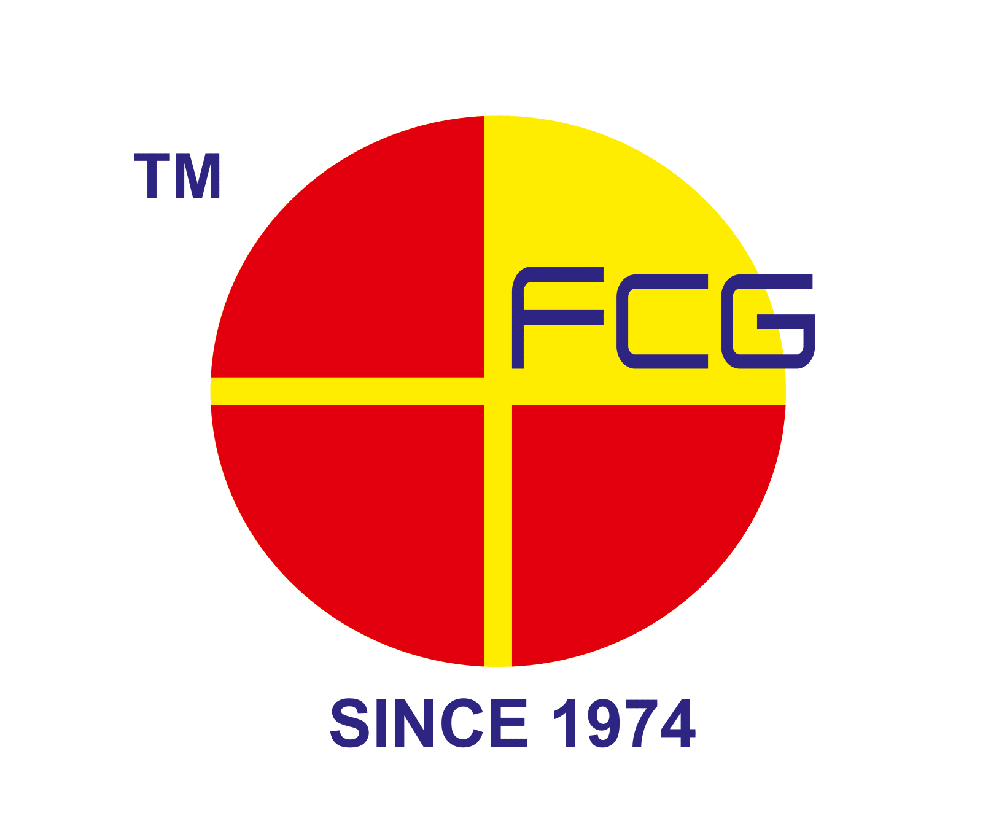











To Schedule Your Free Assessment:
- Email: sales@mygreendot.co.in,
- Phone: +91 8141042060

- Website: www.mygreendot.co.in

