THE SENIOR TALENT RECRUITMENT DISASTER GUIDE FOR SMES
Why 73% of Companies Hire Wrong (And How to Fix It in 30 Days)A Viral-Worthy, Mistake-Proof Framework That SMEs Share Like Crazy

Contents
- The Shocking Truth About SME Hiring 3
- The 7 Deadly Hiring Mistakes (That Everyone Makes) 3
- The MAGNET Framework: How SMEs Beat Big Companies at Hiring 3
- The Hidden Cost Calculator (That Will Shock You) 5
- The 30-Day Hiring Transformation Challenge 6
- Templates (Viral-Worthy Tools) 7
- The Viral Bonus: Hiring Psychology Hacks 8
- Success Stories (Real SMEs, Real Results) 8
- Your Personal Action Checklist 9
- Warning: Common Implementation Mistakes 9
- The Ultimate SME Hiring Advantage 10
- What Happens Next? 10
- About Greendot Management Consultants 11

The Shocking Truth About SME Hiring
Did You Know?
- 73% of companies admit they've hired the wrong person
- Average cost of ONE bad senior hire: ₹34 lakhs
- SMEs lose 40% more talent to competitors due to poor hiring processes
- 89% of hiring failures are due to poor cultural fit, not skills
The Real Problem: Most SMEs hire like it's 1995, then wonder why they can't compete for talent in 2024.

The 7 Deadly Hiring Mistakes (That Everyone Makes)

Mistake #1: The "Gut Feel" Trap
What Happens: "I liked him, let's hire him"
Reality Check: Gut feel has 14% accuracy in predicting job performance
Fix: Use the STAR method + scorecards (templates included)

Mistake #2: The Job Description Disaster
What Happens: Copy-paste boring JDs that attract no one
Reality Check: 76% of candidates never apply because JDs are unclear
Fix: IMPACT Framework (turns JDs into magnets)

Mistake #3: The Salary Guessing Game
What Happens: Offer random numbers and lose good candidates
Reality Check: 67% of candidates reject offers due to poor salary research
Fix: Total Value Calculator (salary + benefits + growth)

Mistake #4: The Interview Chaos
What Happens: Different interviewers ask random questions
Reality Check: Unstructured interviews are only 38% effective
Fix: 90-minute structured process (scripts included)

Mistake #5: The Reference Skip
What Happens: "We'll check later" (but never do)
Reality Check: 95% of reference checks reveal important information
Fix: 5-question reference framework (copy-paste ready)

Mistake #6: The Offer Fumble
What Happens: Verbal offers without clear next steps
Reality Check: 41% of candidates accept competing offers due to poor closing
Fix: 3-step offer process with negotiation scripts

Mistake #7: The Onboarding Vacuum
What Happens: "Figure it out as you go"
Reality Check: 69% of new hires quit within 18 months due to poor onboarding
Fix: 30-60-90-day integration plan

The MAGNET Framework: How SMEs Beat Big Companies at Hiring

M - Market Intelligence
What Big Companies Do: Throw money at problems
What Smart SMEs Do: Use data to win efficiently
Your Intelligence Dashboard:
- Salary benchmarks (3 tools, 5 minutes)
- Competitor analysis (what they offer vs. what you can)
- Candidate psychology (what really motivates senior talent)

A - Attraction System
What Big Companies Do: Generic job posts What Smart SMEs Do: Create irresistible opportunities
The IMPACT Job Description Formula:
- Intro: Company story + role purpose (2 lines)
- Mission: Specific outcomes by timeframes
- Primary: Top 4 responsibilities + metrics
- Abilities: Must-have vs. nice-to-have
- Culture: "You'll thrive if..." indicators
- Total Package: Everything they get + growth path

G - Growth Positioning
What Big Companies Do: Promise stability
What Smart SMEs Do: Promise impact and growth
The Growth Story Script: "In a big company, you're employee #5,847. Here, you're the person who [specific impact]. In 18 months, you could be [clear progression path]."

N - Network Activation
What Big Companies Do:
- Post on multiple job boards and pray for volume
- Run expensive LinkedIn ads targeting thousands
- Use recruiters for passive candidate hunting
- Passive, broadcast approach (spray and pray)
What Smart SMEs Do (The Winning Strategy):
- Direct LinkedIn Outreach: 60–80 personalized messages/week to specific candidates
- Employee Referrals: ₹25k–₹1L bonus system (highest ROI channel)
- Community Deep-Dive: Attend 1–2 industry events/month, build relationships
- Alumni & Vendor Networks: Leverage existing relationships
- Active, targeted approach (precision archery)
Why This Works for SMEs:
- Lower cost per hire (referrals: ₹0–₹1L vs. LinkedIn ads: ₹5–₹15L)
- Higher quality candidates (80% referral success vs. 35% job board)
- Faster response times (direct: 48–72 hours vs. job board: 1–2 weeks)
- Better cultural fit (known networks pre-screen values)`
The Math:
- Big Company: 500 applications → 50 interviews → 10 finalist → 1 hire (cost per hire: ₹8L+)
- Smart SME: 60 direct contacts → 20 screens → 6 interviews → 1 hire (cost per hire: ₹2–3L)
The 4-Channel Sourcing System:
- LinkedIn Direct (40%): 60 targeted contacts/week
- Employee Referrals (30%): ₹25k-₹1L bonus system
- Community Networks (20%): Industry events + alumni groups
- Strategic Portals (10%): Naukri + sector-specific sites

E - Evaluation Excellence
What Big Companies Do: Multiple rounds of confusion
What Smart SMEs Do: 90-minute structured precision
The STAR Interview System:
- 10min: Warm-up + context
- 25min: Career deep-dive (STAR method)
- 30min: Role competencies (scenarios)
- 15min: Culture fit assessment
- 10min: Q&A + close

T - Talent Closing
What Big Companies Do: Slow bureaucracy
What Smart SMEs Do: Fast, personal, compelling
The 3-Step Closing Process:
- Verbal Offer: Same day as final interview
- Written Package: Within 24 hours with total value breakdown
- Personal Follow-up: 2 check-ins during decision period

The Hidden Cost Calculator (That Will Shock You)
Your Bad Hire Cost Reality Check
Fill This Out (Be Honest):
Cost Type | Your Numbers | Calculation | Amount (₹)
Direct Costs
Salary Paid | Monthly: ₹_____ × Months: _____
Recruitment | Time + Ads + Agency
Training | Programs + HR Time
Exit Cost | Notice + Handover
Indirect Costs
Team Impact | Team Size: _____ × Productivity Drop: _____%
Revenue Loss | Missed Deals/Projects: _____
Client Impact | Lost Relationships: _____
TOTAL DISASTER COST |  |  | ₹_______

Reality Check Examples:
- Sales Manager (₹12L salary): Total bad hire cost = ₹34L
- Operations Head (₹15L salary): Total bad hire cost = ₹42L
- IT Manager (₹10L salary): Total bad hire cost = ₹28L
The Prevention Investment ROI
Smart Hiring Investment: ₹3-5 lakhs
Bad Hire Prevention: 70-80% success rate improvement
ROI: 600-800% return in first year

The 30-Day Hiring Transformation Challenge

Week 1: Foundation Blitz
Day 1-2: Audit current process (use Readiness Scorecard) Day 3-4: Rewrite JD using IMPACT framework Day 5-7: Launch 4-channel sourcing, get 15 initial contacts
Week 1 Success Metrics:
- Readiness score improved by 20+ points
- New JD ready (test with 3 internal people)
- 15+ qualified candidate contacts made

Week 2: Pipeline Power
Day 8-10: Screen 8-12 candidates (15-min calls) Day 11-14: Conduct 4-6 structured interviews Week 2 Success Metrics:
- 3-4 candidates shortlisted for finals
- Interview scorecards completed
- References initiated for top 2

Week 3: Decision & Close
Day 15-17: Final rounds + case studies Day 18-21: References + offer preparation Week 3 Success Metrics:
- Final candidate selected
- Complete reference checks
- Offer package approved internally

Week 4: Close & Onboard
Day 22-24: Verbal offer + negotiation Day 25-28: Written offer + follow-up Day 29-30: Acceptance + onboarding prep Week 4 Success Metrics:
- Offer accepted
- Start date confirmed
- 30-60-90-day plan ready

Templates (Viral-Worthy Tools)

Template 1: The LinkedIn Outreach Message That Works
Subject: Quick question about [their expertise area]
Hi [Name],
Saw your work at [Company] in [specific area] - impressive results on [specific achievement].
We're a [brief company description] looking for a [role] to [specific impact]. Not sure if timing is right, but the opportunity might interest you:
• [Compelling aspect 1]
• [Growth opportunity]
• [Unique benefit]
Worth a 10-minute conversation?
Best,
[Your name]
Response Rate: 40-60% vs. 8-12% for generic messages

Template 2: The Reference Check Questions That Reveal Truth
- "How would you rate [Name]'s performance compared to others in similar roles?"
- "What specific achievements are you most proud of from their time with you?"
- "In what situations did they struggle, and how did they handle it?"
- "Would you hire them again for a similar role? Why/why not?"
- "Any advice for their future manager to get the best from them?"

Template 3: The Offer Script That Closes
"Hi [Name], we were really impressed with your background and how you handled our interview process.
I'm excited to offer you the [Role] position. Here's what we're proposing:
Base: ₹[Amount] monthly
Variable: [Structure] with ₹[Potential] upside
Benefits: [Key highlights]
Growth: [Specific path in 12-18 months]
This reflects our strong belief in what you can achieve here. What questions can I answer?"

The Viral Bonus: Hiring Psychology Hacks

Hack #1: The Scarcity Principle
"We're interviewing 3 final candidates this week. I'd love you to be one of them." Why It Works: Creates urgency without pressure

Hack #2: The Peer Proof
"Our last [role] hire said this was the best career move they've made. Let me connect you." Why It Works: Social proof from someone like them

Hack #3: The Growth Vision
"In 18 months, you could be running [specific area]. Here's how..." Why It Works: Appeals to ambition over salary

Hack #4: The Problem Ownership
"This is the challenge we're facing: [specific problem]. How would you approach it?" Why It Works: Makes them invest mentally in the role

Hack #5: The Culture Preview
"Here's how we handle [specific situation that matters to them]..." Why It Works: Shows values alignment early

Success Stories (Real SMEs, Real Results)

Case 1: Manufacturing SME (₹50Cr Revenue)
Before: 6 months to fill Production Manager role
After: 18 days using MAGNET framework
Result: New hire delivered 23% efficiency improvement in 90 days

Case 2: Tech Services (₹25Cr Revenue)
Before: 3 bad hires in Project Management (cost: ₹67L)
After: Structured process, perfect cultural fit
Result: Zero turnover in senior hires for 18 months

Case 3: Trading Company (₹100Cr Revenue)
Before: Lost 4 candidates to salary negotiations
After: Total value positioning + growth story
Result: 85% offer acceptance rate, 30% lower cash outlay

Your Personal Action Checklist
This Week (Foundation)
- Complete Readiness Assessment (Score: ___/80)
- Identify your #1 hiring mistake from the 7 deadly sins
- Rewrite one job description using IMPACT framework
- Calculate the cost of your last bad hire
Next Week (Execution)
- Set up LinkedIn sourcing system
- Create referral bonus program
- Design interview scorecard for your role
- Plan your first structured interview
Month 1 (Transformation)
- Complete 30-day challenge
- Measure improvement in candidate quality
- Calculate time-to-hire improvement
- Share this guide with 3 other business owners

Warning: Common Implementation Mistakes

Mistake #1: Perfection Paralysis
Wrong: "Let me perfect everything before starting"
Right: Start with one role, improve as you go

Mistake #2: Tool Obsession
Wrong: "I need expensive ATS software first"
Right: Excel + templates work perfectly for SMEs

Mistake #3: Owner Dependency
Wrong: "Only I can interview senior candidates"
Right: Train 2-3 team members in structured interviewing

Mistake #4: Process Skip
Wrong: "This candidate is obviously good, let's skip steps"
Right: Trust the process, even with "obvious" wins

The Ultimate SME Hiring Advantage
Big Companies Have: Money, brand, resources S
mart SMEs Have: Speed, flexibility, impact, personal attention
Your Competitive Edge:
- 2-week decision cycles vs. 6-8 weeks
- Direct access to leadership vs. corporate hierarchy
- Visible impact vs. being a small cog
- Growth opportunities vs. slow promotions
- Personal attention vs. HR automation
Use This Positioning: "You could join [Big Company] and be employee #5,847, or join us and be the person who [specific impact]. Which excites you more?"

What Happens Next?
If This Guide Helped You:
- Implement immediately (start with Week 1 actions)
- Share with peer SME owners (they'll thank you)
- Track your improvements (time, quality, cost)
- Join our SME hiring community (link in footer)
If You Need Expert Help:
- Free Hiring Audit: We'll assess your current process
- Done-for-You Recruitment: We handle senior roles ₹50k+/month
- Team Training: We'll train your team on this framework
- Custom Solutions: Tailored for your industry/size

About Greendot Management Consultants
greendot is a leading management consulting firm specializing in operational excellence, workplace transformation, and sustainable business improvement. With 25+ years of experience and 11000+ successful implementations, we help companies achieve measurable, lasting results.

Our Services

greendot – Helping SMEs and Mid-Sized Companies Achieve Massive, Sustainable Sales Growth.








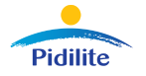
Few CLIENTS Of Greendot :








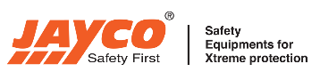



















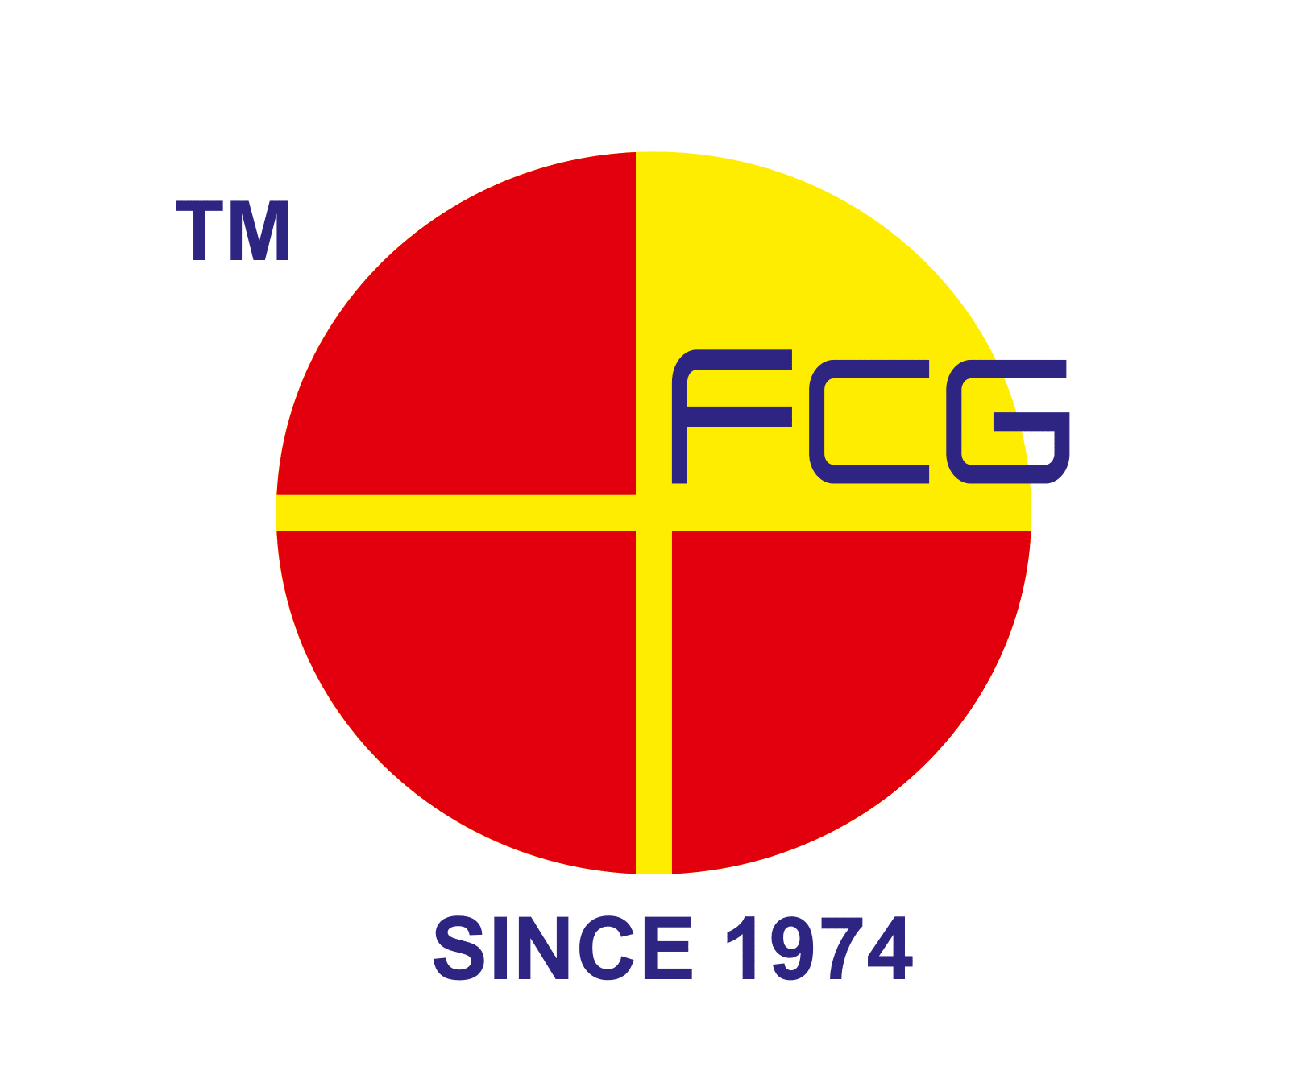











To Schedule Your Free Assessment:
- Email: sales@mygreendot.co.in,
- Phone: +91 8141042060

- Website: www.mygreendot.co.in

